

**20CYS404**

**Android Application Development**

**End Sem Lab Exam**

Add data to database

**Name: S Sridharan**

**Roll No: CH.EN.U4CYS21080**

**END SEM LAB EXAM**

**Aim:**

To develop an application for course registration

**Code:**

**File : activity_main.xml**

<?xml version="1.0" encoding="utf-8"?>  
<RelativeLayout xmlns:android="http://schemas.android.com/apk/res/android"  
 android:layout_width="match_parent"  
 android:layout_height="match_parent"  
 android:padding="16dp">  
  
 <!-- Logo ImageView -->  
 <ImageView  
 android:id="@+id/logo"  
 android:layout_width="200dp"  
 android:layout_height="80dp"  
 android:src="@drawable/logo"  
 android:scaleType="centerInside"  
 android:layout_centerHorizontal="true"  
 android:layout_marginBottom="24dp" /> <!-- Adds space below the logo -->  
  
 <!-- Name EditText -->  
 <EditText  
 android:id="@+id/et_name"  
 android:layout_width="match_parent"  
 android:layout_height="wrap_content"  
 android:hint="Name"  
 android:layout_below="@id/logo"  
 android:layout_marginTop="8dp" />  
  
 <!-- Course EditText -->  
 <EditText  
 android:id="@+id/et_course"  
 android:layout_width="match_parent"  
 android:layout_height="wrap_content"  
 android:hint="Course"  
 android:layout_below="@id/et_name"  
 android:layout_marginTop="8dp" />  
  
 <!-- Fees EditText -->  
 <EditText  
 android:id="@+id/et_fees"  
 android:layout_width="match_parent"  
 android:layout_height="wrap_content"  
 android:hint="Fees"  
 android:layout_below="@id/et_course"  
 android:layout_marginTop="8dp" />  
  
 <!-- Save Button -->  
 <Button  
 android:id="@+id/btn_save"  
 android:layout_width="wrap_content"  
 android:layout_height="wrap_content"  
 android:text="Save"  
 android:layout_below="@id/et_fees"  
 android:layout_marginTop="16dp"  
 android:layout_alignParentStart="true" />  
  
 <!-- View Button -->  
 <Button  
 android:id="@+id/btn_view"  
 android:layout_width="wrap_content"  
 android:layout_height="wrap_content"  
 android:text="View"  
 android:layout_below="@id/et_fees"  
 android:layout_marginTop="16dp"  
 android:layout_toEndOf="@id/btn_save"  
 android:layout_marginStart="16dp" /> <!-- Adds margin between buttons -->  
  
 <!-- Table Layout for Records -->  
 <TableLayout  
 android:id="@+id/tableLayout"  
 android:layout_width="match_parent"  
 android:layout_height="wrap_content"  
 android:layout_below="@id/btn_save"  
 android:layout_marginTop="16dp"  
 android:stretchColumns="1" />  
  
 <!-- Footer TextView -->  
 <TextView  
 android:id="@+id/text_name"  
 android:layout_width="wrap_content"  
 android:layout_height="wrap_content"  
 android:text="Sridharan [CH.EN.U4CYS21080]"  
 android:textSize="25sp"  
 android:textColor="#000000"  
 android:layout_alignParentBottom="true"  
 android:layout_centerHorizontal="true"  
 android:layout_marginBottom="20dp"/>  
  
</RelativeLayout>

**File: MainActivity.java**

package com.example.labexam;  
  
import android.os.Bundle;  
  
import androidx.activity.EdgeToEdge;  
import androidx.appcompat.app.AppCompatActivity;  
import androidx.core.graphics.Insets;  
import androidx.core.view.ViewCompat;  
import androidx.core.view.WindowInsetsCompat;  
  
import android.content.ContentValues;  
import android.database.Cursor;  
import android.database.sqlite.SQLiteDatabase;  
import android.os.Bundle;  
import android.view.View;  
import android.widget.Button;  
import android.widget.EditText;  
import android.widget.TableLayout;  
import android.widget.TableRow;  
import android.widget.TextView;  
import android.widget.Toast;  
  
  
import com.google.firebase.FirebaseApp;  
import com.google.firebase.database.DataSnapshot;  
import com.google.firebase.database.DatabaseError;  
import com.google.firebase.database.DatabaseReference;  
import com.google.firebase.database.FirebaseDatabase;  
import com.google.firebase.database.ValueEventListener;  
import java.util.concurrent.atomic.AtomicInteger;  
  
  
  
import androidx.appcompat.app.AppCompatActivity;  
  
public class MainActivity extends AppCompatActivity {  
 private EditText etName, etCourse, etFees;  
 private Button btnSave, btnView;  
 private TableLayout tableLayout;  
 private SQLiteDatabase db;  
 private String selectedName; // To track the selected record for editing  
  
 @Override  
 protected void onCreate(Bundle savedInstanceState) {  
 super.onCreate(savedInstanceState);  
 setContentView(R.layout.*activity_main*);  
  
 etName = findViewById(R.id.*et_name*);  
 etCourse = findViewById(R.id.*et_course*);  
 etFees = findViewById(R.id.*et_fees*);  
 btnSave = findViewById(R.id.*btn_save*);  
 btnView = findViewById(R.id.*btn_view*);  
 tableLayout = findViewById(R.id.*tableLayout*);  
  
 // Initialize SQLite database  
 DBHelper dbHelper = new DBHelper(this);  
 db = dbHelper.getWritableDatabase();  
  
 // Save record to SQLite  
 btnSave.setOnClickListener(v -> saveRecord());  
  
 // View records in a table format  
 btnView.setOnClickListener(v -> viewRecords());  
 }  
  
 private void saveRecord() {  
 String name = etName.getText().toString();  
 String course = etCourse.getText().toString();  
 String fees = etFees.getText().toString();  
  
 if (name.isEmpty() || course.isEmpty() || fees.isEmpty()) {  
 Toast.*makeText*(this, "Please fill all fields", Toast.*LENGTH_SHORT*).show();  
 return;  
 }  
  
 // Save to SQLite  
 ContentValues values = new ContentValues();  
 values.put("name", name);  
 values.put("course", course);  
 values.put("fees", fees);  
  
 if (selectedName == null) {  
 db.insert("CourseTable", null, values);  
 Toast.*makeText*(this, "Record Added", Toast.*LENGTH_SHORT*).show();  
 } else {  
 db.update("CourseTable", values, "name=?", new String[]{selectedName});  
 Toast.*makeText*(this, "Record Updated", Toast.*LENGTH_SHORT*).show();  
 selectedName = null; // Reset the selected name  
 }  
  
 clearFields();  
 viewRecords(); // Refresh the records displayed  
 }  
  
 private void viewRecords() {  
 tableLayout.removeAllViews();  
 tableLayout.setVisibility(View.*VISIBLE*);  
  
 Cursor cursor = db.rawQuery("SELECT * FROM CourseTable", null);  
 if (cursor.moveToFirst()) {  
 do {  
 TableRow row = new TableRow(this);  
 TextView name = new TextView(this);  
 TextView course = new TextView(this);  
 TextView fees = new TextView(this);  
 Button btnEdit = new Button(this);  
 Button btnDelete = new Button(this);  
  
 String recordName = cursor.getString(1);  
 name.setText(recordName);  
 course.setText(cursor.getString(2));  
 fees.setText(cursor.getString(3));  
  
 btnEdit.setText("Edit");  
 btnEdit.setOnClickListener(v -> editRecord(recordName, course.getText().toString(), fees.getText().toString()));  
  
 btnDelete.setText("Delete");  
 btnDelete.setOnClickListener(v -> deleteRecord(recordName));  
  
 row.addView(name);  
 row.addView(course);  
 row.addView(fees);  
 row.addView(btnEdit);  
 row.addView(btnDelete);  
 tableLayout.addView(row);  
 } while (cursor.moveToNext());  
 }  
 cursor.close();  
 }  
  
 private void editRecord(String name, String course, String fees) {  
 etName.setText(name);  
 etCourse.setText(course);  
 etFees.setText(fees);  
 selectedName = name; // Store the name of the selected record for editing  
 btnSave.setText("Update");  
 }  
  
 private void deleteRecord(String name) {  
 db.delete("CourseTable", "name=?", new String[]{name});  
 Toast.*makeText*(this, "Record Deleted", Toast.*LENGTH_SHORT*).show();  
 viewRecords(); // Refresh the records displayed  
 }  
  
 private void clearFields() {  
 etName.setText("");  
 etCourse.setText("");  
 etFees.setText("");  
 btnSave.setText("Save"); // Reset button text  
 }  
}

File: DBHelper

package com.example.labexam;  
  
import android.content.Context;  
import android.database.sqlite.SQLiteDatabase;  
import android.database.sqlite.SQLiteOpenHelper;  
  
public class DBHelper extends SQLiteOpenHelper {  
 private static final String *DATABASE_NAME* = "courses.db";  
 private static final int *DATABASE_VERSION* = 1;  
  
 public DBHelper(Context context) {  
 super(context, *DATABASE_NAME*, null, *DATABASE_VERSION*);  
 }  
  
 @Override  
 public void onCreate(SQLiteDatabase db) {  
 String CREATE_COURSE_TABLE = "CREATE TABLE CourseTable (" +  
 "id INTEGER PRIMARY KEY AUTOINCREMENT," +  
 "name TEXT," +  
 "course TEXT," +  
 "fees TEXT)";  
 db.execSQL(CREATE_COURSE_TABLE);  
 }  
  
 @Override  
 public void onUpgrade(SQLiteDatabase db, int oldVersion, int newVersion) {  
 db.execSQL("DROP TABLE IF EXISTS CourseTable");  
 onCreate(db);  
 }  
}

**File: Android_manifest.xml**

<?xml version="1.0" encoding="utf-8"?>  
<manifest xmlns:android="http://schemas.android.com/apk/res/android"  
 xmlns:tools="http://schemas.android.com/tools">  
  
 <application  
 android:allowBackup="true"  
 android:dataExtractionRules="@xml/data_extraction_rules"  
 android:fullBackupContent="@xml/backup_rules"  
 android:icon ="@drawable/logo"  
 android:label="@string/app_name"  
 android:roundIcon="@mipmap/ic_launcher_round"  
 android:supportsRtl="true"  
 android:theme="@style/Theme.Labexam"  
 tools:targetApi="31">  
 <activity  
 android:name=".MainActivity"  
 android:exported="true">  
 <intent-filter>  
 <action android:name="android.intent.action.MAIN" />  
  
 <category android:name="android.intent.category.LAUNCHER" />  
 </intent-filter>  
 </activity>  
 </application>  
  
</manifest>

**Output:**

Record added and displayed

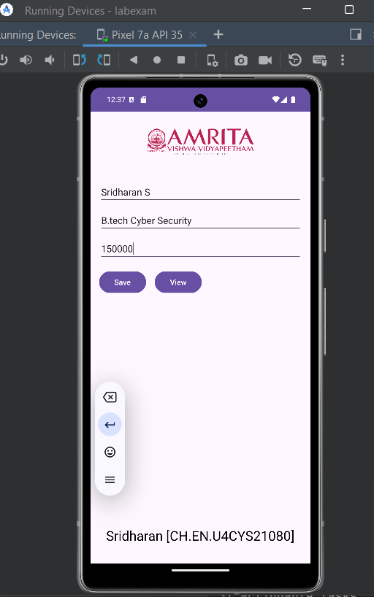 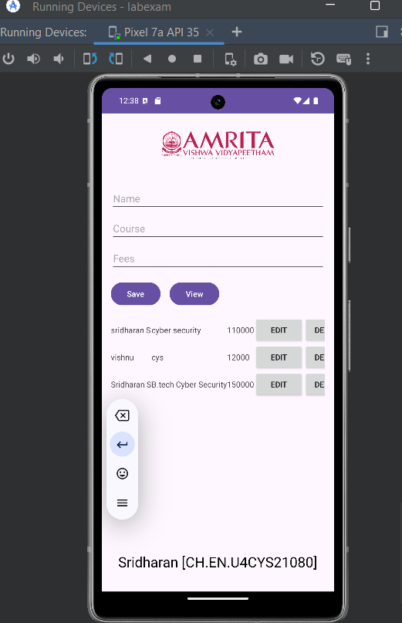

Record updated and record deleted are performed below

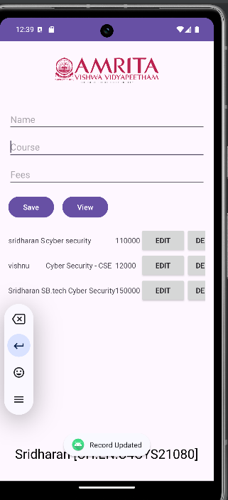 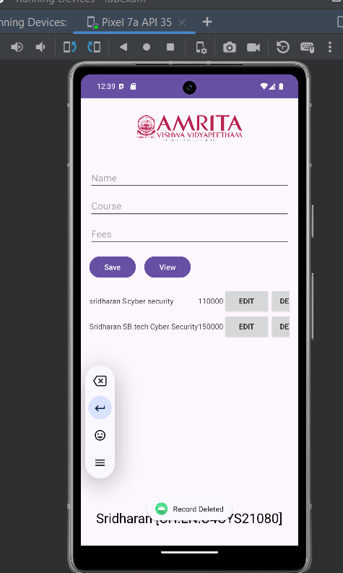

Sqllite database connection and records

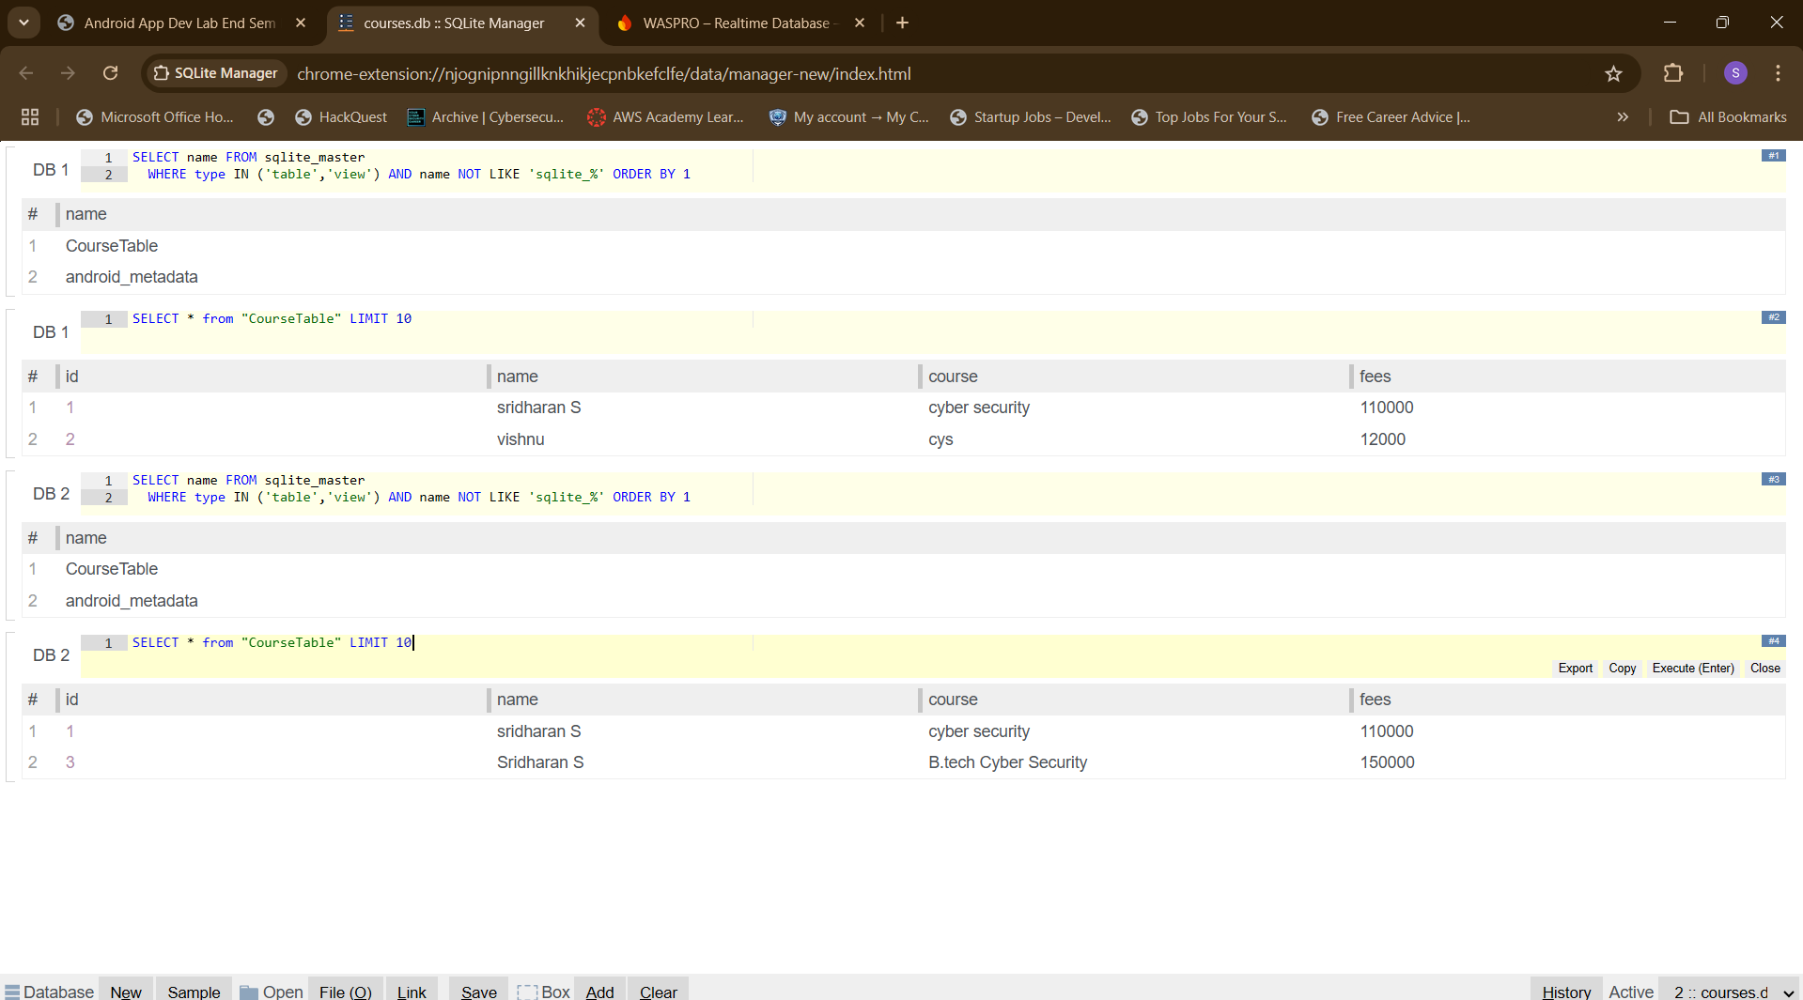

Firebase Datbase connection

